Data Science Project Training Report

on

Machine Learning Domain Projects for Sleep Disorder Prediction

BACHELOR OF TECHNOLOGY

Session 2024-25
in

Computer Engineering

By
Rudraksh Bhadauria
2300320150047
Utkarsh Saxena
2300320150066

Dr. Shelley Gupta

Associate Professor

DEPARTMENT OF INFORMATION TECHNOLOGY

ABES ENGINEERING COLLEGE, GHAZIABAD
 |  | 
AFFILIATED TO
DR. A.P.J. ABDUL KALAM TECHNICAL UNIVERSITY, U.P., LUCKNOW
(Formerly UPTU)

Student’s Declaration

We hereby declare that the work being presented in this report entitled Sleep Disorder Prediction is an authentic record of our own work carried out under the supervision of Dr. Shelley Gupta, Associate Professor, Information Technology.

Date:

Signature of student
Department: Computer Engineering

This is to certify that the above statement made by the candidate(s) is correct to the best of my knowledge.

Signature of HOD Signature of Teacher
Prof. (Dr.) Amrita Jyoti Dr. Shelley Gupta
Information Technology Associate Professor
Information Technology

Date: ....

Table of Contents

S. No. | Contents | Page No.
1 | Student’s Declaration | I
2 | Abstract | 1
3 | Introduction | 2-3
4 | Literature review | 4-5
5 | Implementation | 6-7
6 | Data Visualization | 8-9
10 | Prediction models | 10-12
11 | Conclusion | 13
12 | Future work | 14
14 | References | 15

Abstract

Sleep disorders, such as Insomnia and Sleep Apnea, significantly impact quality of life and health outcomes. This project aims to predict sleep disorders using data-driven machine learning techniques. By analyzing lifestyle, medical, and demographic variables, such as sleep duration, physical activity, stress levels, and BMI, we train and evaluate predictive models. The analysis focuses on two classification algorithms: Decision Tree and Random Forest. The Random Forest model achieves the highest accuracy of 89%, offering a robust approach to predicting sleep disorders.

Here are the keywords for the project:
- Sleep Disorders
- Insomnia
- Sleep Apnea
- Machine Learning
- Random Forest Classifier
- Decision Tree Classifier
- Sleep Health and Lifestyle Dataset
- Data Preprocessing
- Feature Engineering
- Exploratory Data Analysis (EDA)
- BMI
- Physical Activity
- Stress Levels
- Predictive Modeling
- Classification Algorithms
- Accuracy
- F1-Score
- Confusion Matrix
- Lifestyle Variables
- Health Prediction Models

Introduction

Sleep is a critical aspect of overall health, with disorders such as Insomnia and Sleep Apnea significantly affecting productivity, physical health, and mental well-being. Despite their prevalence, early detection of these disorders remains a challenge due to the complex interplay of various biological and lifestyle factors. This project utilizes the Sleep Health and Lifestyle Dataset, comprising 400 samples and 13 features, to predict sleep disorders and their types. The dataset includes variables such as gender, age, occupation, sleep duration, sleep quality, physical activity level, stress levels, BMI category, blood pressure, heart rate, daily steps, and the presence or absence of sleep disorders. By analyzing these variables, the project seeks to identify key predictors like BMI, stress levels, and sleep quality that play a vital role in determining the likelihood of sleep disorders.
The methodology involves several steps, beginning with data preprocessing to handle missing values, encode categorical data, and standardize numerical features. This is followed by exploratory data analysis (EDA) to uncover patterns, trends, and relationships within the data, such as correlations between stress levels and sleep quality. Feature engineering is employed to enhance predictive accuracy, for instance, by categorizing BMI into distinct ranges. Machine learning models, such as Logistic Regression, Random Forest, and Support Vector Machines (SVM), are trained and evaluated using metrics like accuracy, precision, recall, and F1-score to ensure robust predictions. The Receiver Operating Characteristic (ROC) curve is used to measure the balance between sensitivity and specificity of the models.
The project aims not only to predict the presence and type of sleep disorders but also to provide actionable insights for health practitioners and researchers. These insights can guide the development of personalized interventions and preventive strategies, such as stress management programs or recommendations for physical activity. By leveraging machine learning, this study contributes to the creation of scalable and cost-effective tools for early diagnosis, ultimately enhancing health outcomes and improving quality of life for individuals at risk of sleep disorders.

Literature review

Sleep disorders, such as Insomnia and Sleep Apnea, significantly affect individuals' quality of life and are a growing concern worldwide. Leveraging machine learning (ML) for predicting and diagnosing these disorders has emerged as an innovative approach in health research. This literature review outlines the progress in this domain, emphasizing the importance of feature selection, algorithmic advancements, and evaluation methods.
1.Importance of Feature Selection
Previous studies have highlighted the critical role of lifestyle and physiological factors in predicting sleep disorders:
- BMI and Obesity: Research shows a strong correlation between higher BMI categories and the prevalence of sleep disorders, particularly Sleep Apnea.
- Stress and Physical Activity: High stress levels and low physical activity are linked to poor sleep quality, contributing to conditions like Insomnia.
- Demographic Variables: Factors such as gender, age, and occupation influence sleep patterns, with males being more susceptible to Insomnia and females more prone to Sleep Apnea.
2.Machine Learning in Sleep Disorder Prediction
Several studies have utilized ML to analyze complex datasets and uncover patterns that traditional methods might overlook:
- Decision Tree Classifiers: Known for their simplicity and interpretability, Decision Trees effectively classify sleep disorders by identifying decision rules based on key features. However, their tendency to overfit limits their generalizability.
- Random Forest Classifiers: An ensemble method that builds multiple trees and merges their results. Random Forest models have demonstrated superior performance in handling imbalanced datasets and improving prediction accuracy.
- Deep Learning Approaches: While computationally expensive, neural networks have been applied for sleep stage detection and complex pattern recognition in sleep-related datasets. However, they require large datasets to avoid overfitting and maintain model robustness.
3.Evaluation Metrics
Evaluation metrics play a crucial role in assessing the effectiveness of prediction models:
- Accuracy: While it measures overall correctness, it may be misleading in imbalanced datasets.
- Precision, Recall, and F1-Score: These metrics provide insights into a model’s performance, particularly for minority classes. Studies report that Random Forest achieves higher F1-scores, indicating better balance between precision and recall.
- Confusion Matrix: Visualizing true positives, false positives, and errors aids in understanding model reliability and areas of improvement.

4.Gaps and Opportunities
Despite advancements, challenges remain:
- Limited datasets restrict the application of ML in diverse populations.
- Feature engineering and preprocessing require domain expertise for optimal results.
- Real-time prediction models for continuous monitoring are still underexplored.

IMPLEMENTATION

The implementation of this project involves multiple stages, including data preprocessing, exploratory data analysis (EDA), feature engineering, model training, and evaluation. This section outlines the methodologies and tools used at each stage for predicting sleep disorders using machine learning algorithms.

1. Data Pre processing
The dataset contains 400 rows and 13 features, with variables like gender, age, BMI, stress level, and presence or absence of sleep disorders. Key preprocessing steps include:
- Handling Missing Values: Replacing null values in the Sleep Disorder column with 'None' since these signify the absence of a disorder.
- Splitting Features: Separating Blood Pressure into Systolic_BP and Diastolic_BP for better interpretability.
- Label Encoding: Converting categorical variables (e.g., Gender, BMI Category) into numerical values using label encoding to make them compatible with ML algorithms.
- Removing Redundant Columns: Dropping irrelevant columns like Person_ID to avoid bias in modeling.
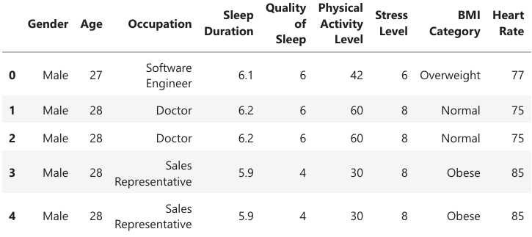

2. Exploratory Data Analysis (EDA)
EDA helps uncover trends and relationships within the dataset:
- Distribution Analysis: Histograms and count plots for variables like Sleep Duration, Quality of Sleep, and Stress Level reveal data distribution and potential imbalances.
- Correlation Matrix: A heatmap visualizes the relationships between features, identifying significant correlations that can inform model building.
- Feature Importance: Initial analysis suggests that BMI, stress levels, and physical activity strongly correlate with sleep disorders.
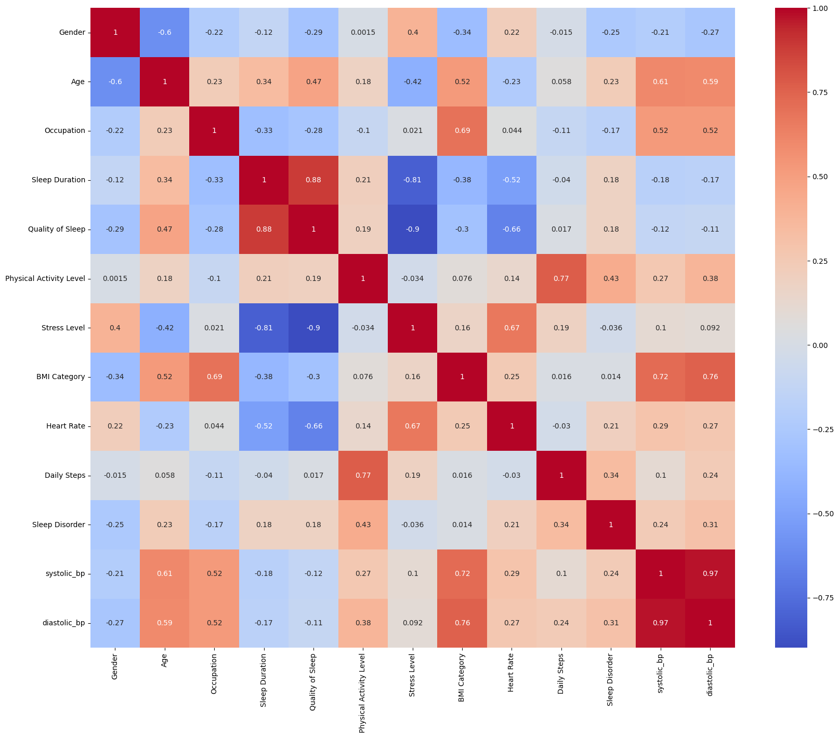
Fig.2: Coorelation Matrix
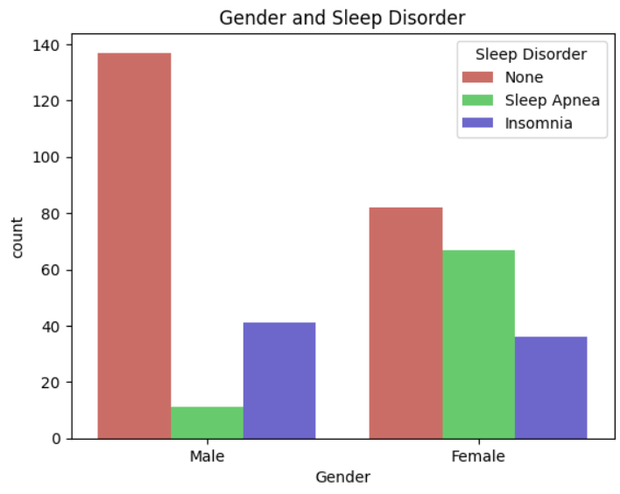
Fig.3: Gender and Sleep

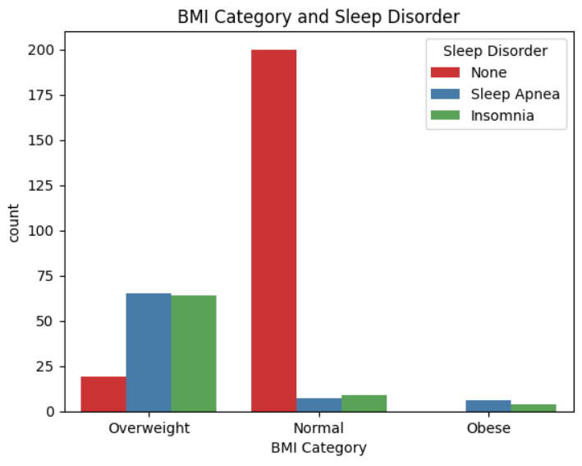
Fig.4: BMI Category and Sleep Disorder
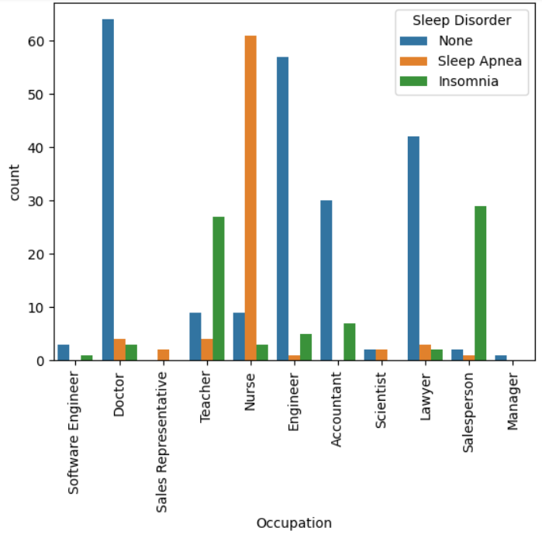
Fig.5: Effect of Occupation on Sleep Disorder

3. Model Training
Two classification models were selected for comparison:

(a) Decision Tree Classifier
- Algorithm: A simple, tree-based model that splits data iteratively based on feature importance.
- Training: The dataset was split into training (70%) and testing (30%) sets using train_test_split.
- Hyperparameters: Default settings were used for the Decision Tree.
- Results: Achieved a training accuracy of 93.48% and a testing accuracy of 87%.

(b) Random Forest Classifier
- Algorithm: An ensemble learning method that builds multiple decision trees and averages their predictions for improved accuracy and robustness.
- Hyperparameters: Utilized 100 estimators and set random_state=42 for reproducibility.
- Results: Achieved a training accuracy of 93.48% and a testing accuracy of 89%, outperforming the Decision Tree.

Prediction models
Two classification models were implemented and evaluated:
- Decision Tree Classifier
  - Training Accuracy: 93.48%
  - Testing Accuracy: 87%
  - The Decision Tree model showed good interpretability, making it suitable for understanding the impact of different features on sleep disorders.
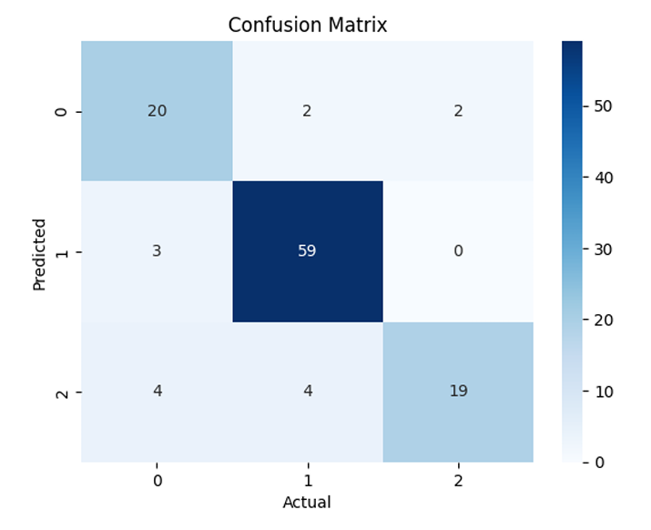
- Random Forest Classifier
  - Training Accuracy: 93.48%
  - Testing Accuracy: 89%
  - Outperformed the Decision Tree by leveraging multiple decision trees to enhance generalizability and reduce overfitting.
  - 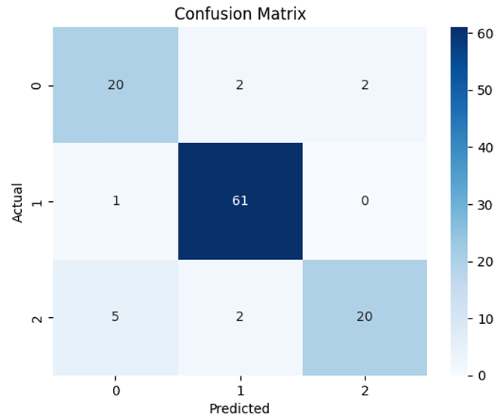
Performance Metrics:
- Accuracy: Random Forest (89%) vs. Decision Tree (87%)
- F1-Score: Random Forest achieved a higher weighted average F1-score (0.86) compared to Decision Tree (0.84).
- Confusion matrices confirmed fewer false positives and higher prediction reliability for the Random Forest model. 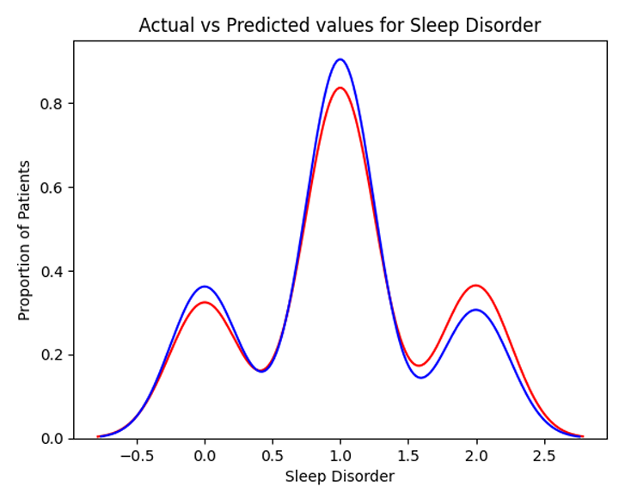

Conclusion

The Sleep Disorder Prediction project successfully demonstrates the application of machine learning in the healthcare domain. By analyzing lifestyle and physiological variables, such as BMI, stress levels, and physical activity, the project provides actionable insights into factors contributing to sleep disorders like Insomnia and Sleep Apnea. Key conclusions from the study are:
- Feature Impact:
  - BMI and Obesity: Individuals with higher BMI categories (Overweight and Obese) are more likely to experience sleep disorders.
  - Stress and Physical Activity: High stress levels and low physical activity significantly increase the risk of sleep disorders.
  - Gender and Occupation: Gender-specific trends show that males are more prone to Insomnia, while females have a higher likelihood of Sleep Apnea. Certain occupations, like nursing, are associated with elevated risks of sleep disorders.
- Model Performance:
  - The Random Forest Classifier emerged as the most effective model, achieving an accuracy of 89% and a weighted average F1-score of 0.86. Its ensemble approach helped minimize overfitting and enhanced generalizability.
  - The Decision Tree Classifier, while achieving comparable training accuracy, showed lower testing accuracy (87%) and slightly poorer performance on minority classes.
- Insights from Data Analysis:
  - Exploratory Data Analysis (EDA) revealed strong correlations between sleep disorders and lifestyle variables, emphasizing the importance of comprehensive data collection in predictive modeling.
- Strengths and Limitations:
  - Strength: This project highlights the potential of machine learning for healthcare prediction, offering scalable and interpretable solutions.
  - Limitation: The dataset, while diverse, may not be large or varied enough to generalize findings across populations.
- Applications:
  - The findings can aid healthcare professionals in identifying high-risk individuals and formulating preventive strategies.
  - Employers in high-stress occupations could use these insights to promote better sleep health among employees.

FUTURE WORK

- Expanding Data Sources: Integrate additional datasets to improve model generalizability.
- Feature Engineering: Explore advanced techniques to uncover hidden patterns in lifestyle and medical data.
- Deep Learning Models: Implement neural networks to capture complex, non-linear relationships.
- Real-Time Prediction: Develop scalable models for continuous monitoring and prediction of sleep disorders.

GITHUB REPOSITORY LINK

Link-: https://github.com/rudraksh1612/DS-Project.git

REFERENCES

- Breiman, L. (2001). Random Forests. Machine Learning, 45(1), 5-32. https://doi.org/10.1023/A:1010933404324
- Hastie, T., Tibshirani, R., & Friedman, J. (2009). The elements of statistical learning: Data mining, inference, and prediction. Springer. https://doi.org/10.1007/978-0-387-84858-7
- Goodfellow, I., Bengio, Y., & Courville, A. (2016). Deep learning. MIT Press.
- Scikit-learn developers. (n.d.). Scikit-learn documentation. Retrieved from https://scikit-learn.org/stable/
- Van Dongen, H. P., & Dinges, D. F. (2003). Sleep, circadian rhythms, and psychomotor vigilance. Clinical Sports Medicine, 22(4), 655-674. https://doi.org/10.1016/S0278-5919(03)00009-6
- Basner, M., & Dinges, D. F. (2011). Maximizing sensitivity of the psychomotor vigilance test (PVT) to sleep loss. Sleep, 34(5), 581-591. https://doi.org/10.1093/sleep/34.5.581
- Sleep Health and Lifestyle Dataset. (n.d.). [Dataset]. Retrieved from the project repository.
- Waskom, M., & the Seaborn Development Team. (n.d.). Seaborn: Statistical data visualization. Retrieved from https://seaborn.pydata.org/
- Hunter, J. D. (2007). Matplotlib: A 2D graphics environment. Computing in Science & Engineering, 9(3), 90-95. https://doi.org/10.1109/MCSE.2007.55
- American Academy of Sleep Medicine (AASM). (n.d.). Resources and guidelines for diagnosing and managing sleep disorders. Retrieved from https://aasm.org

